Name: Kanak Agrawal

Email: [Kanakagrawal2001@gmail.com](mailto:Kanakagrawal2001@gmail.com)

Date:14-02-2024

Day-18 Assignment(Azure)

**Creating Delta Table**

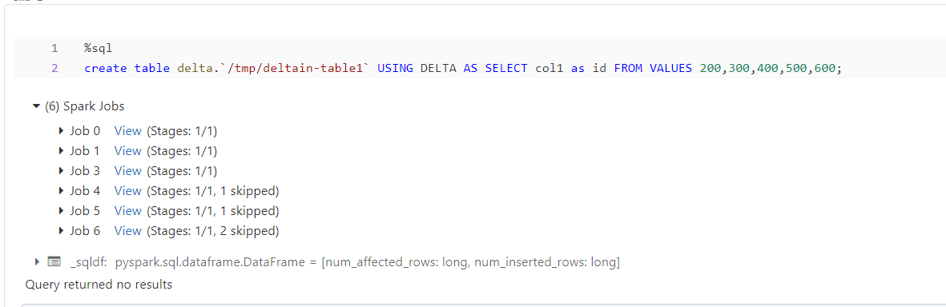

**Select Operation on delta Table**

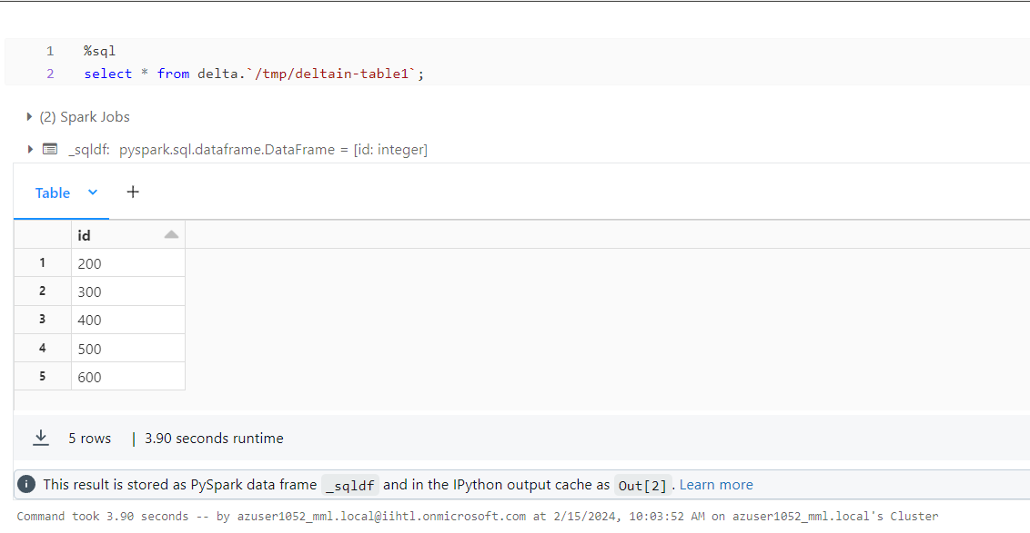

**Streaming Data**

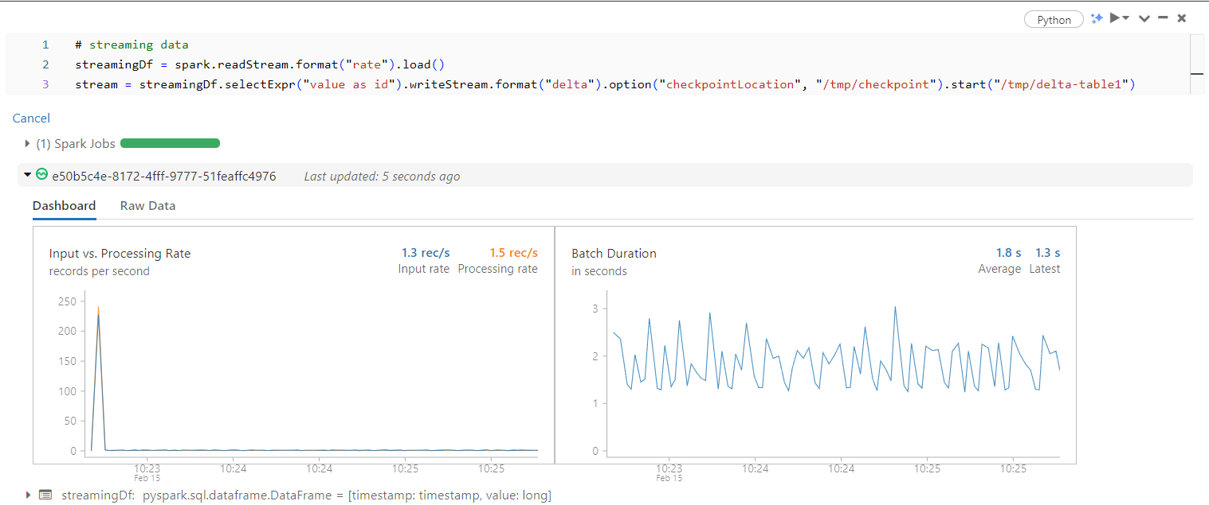

**Update for delta table**

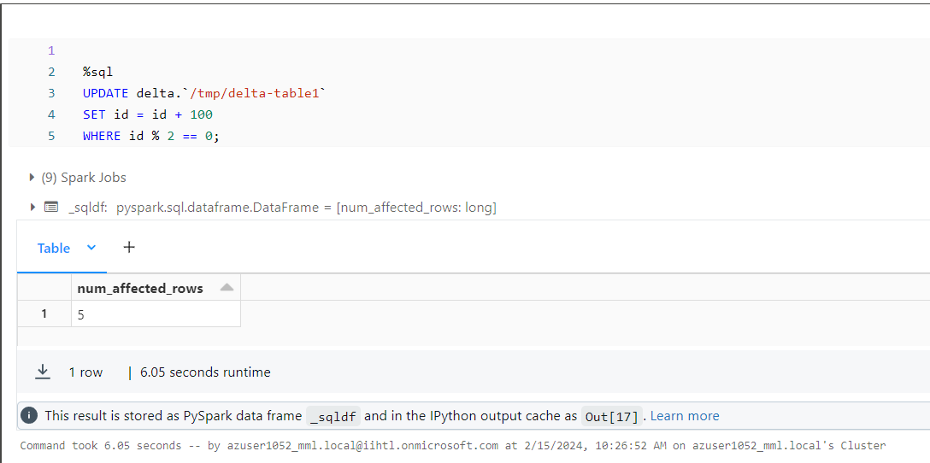

**Delete for delta table**

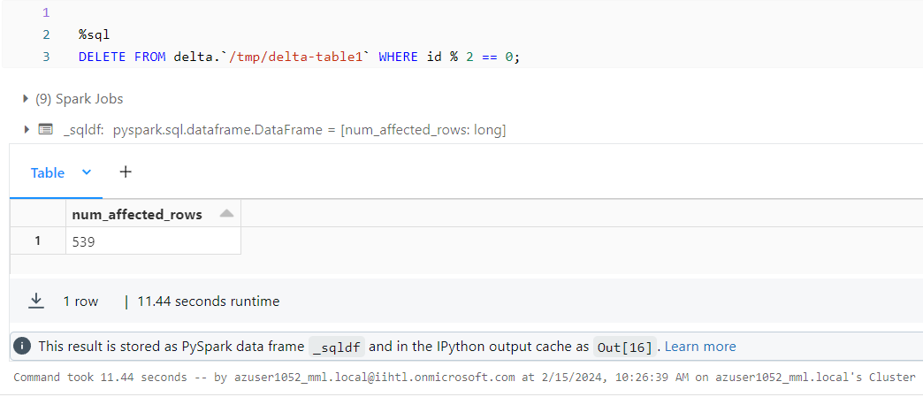

**Creating view for delta table**

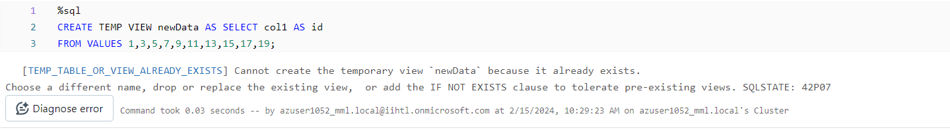

**Merge for delta table**

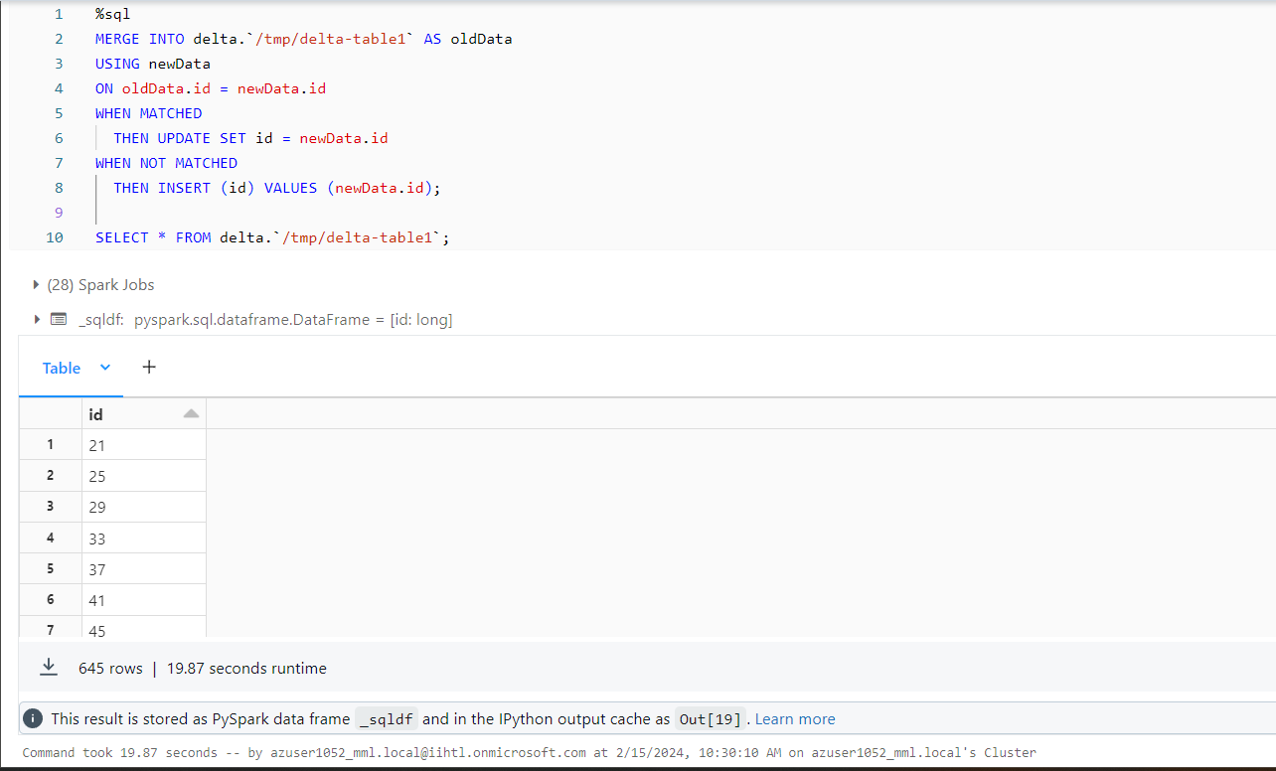

**Streaming data after the changes**

